Laxmi Charitable Trust’s
Sheth L.U.J College of Arts & Sir M.V. College of Science and Commerce
Department of Information Technology (B.Sc.I.T Semester V)
Data Visualization with Power BI and Tableau
Practical – XI
Roll No.: T031 | Name: Ishita Patel
Class: TYIT | Batch: 02
Date of Assignment: 01-09-2026 | Date/Time of Submission: 01-09-2026
Part B – Program
Implementing Advanced Visualization Techniques and Customizations
a) Create slope charts and lollipop charts
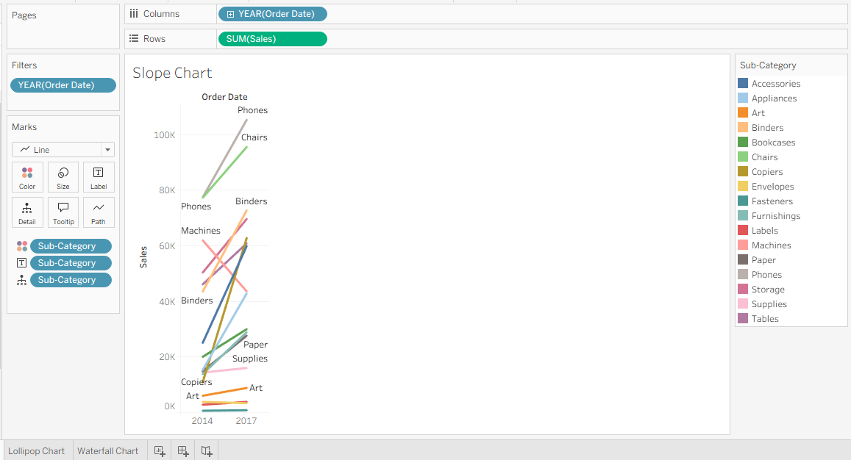
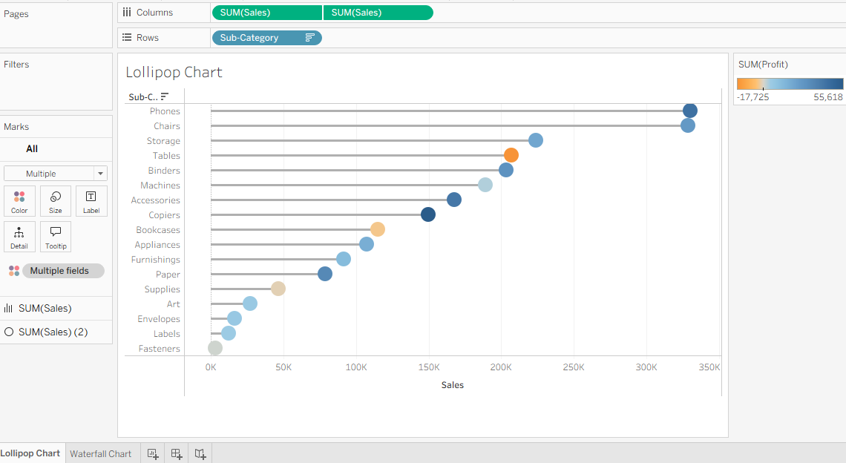
b) Design waterfall charts
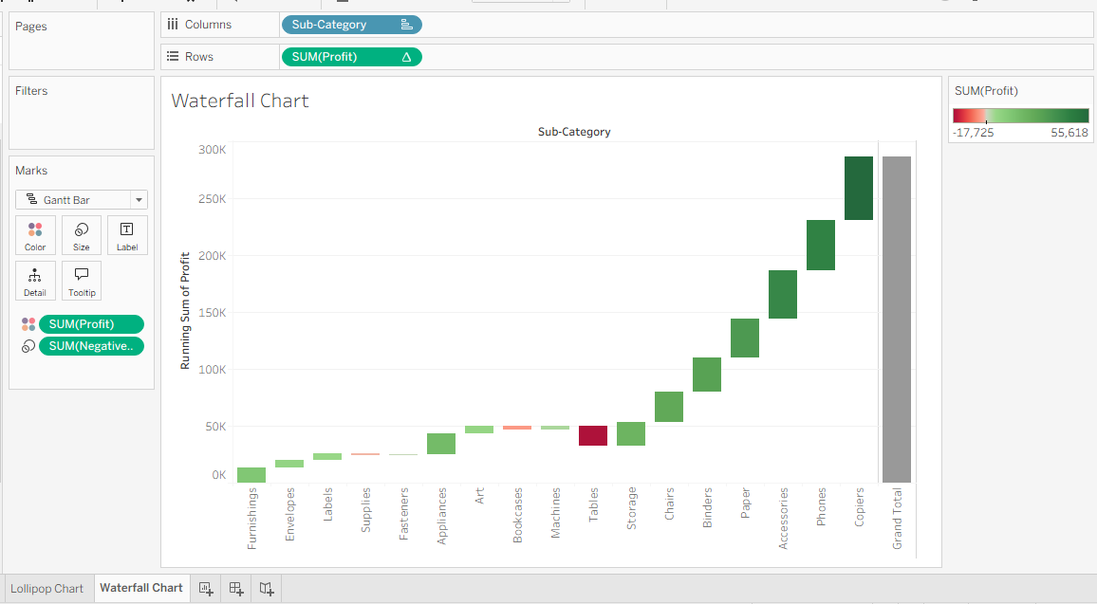

c) Build sparklines for trend analysis
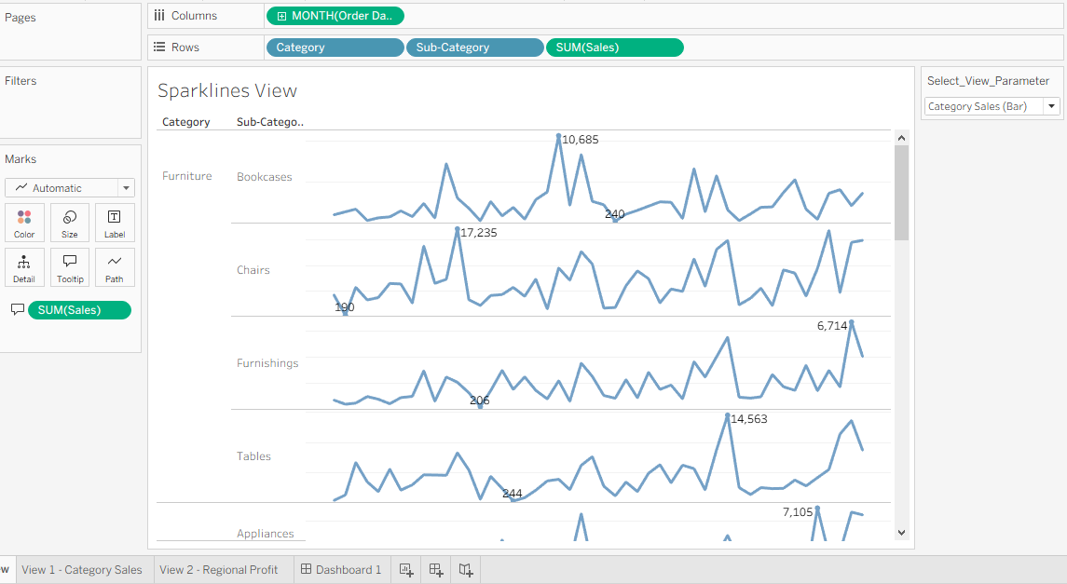

d) Implement sheet swapping for dynamic dashboards
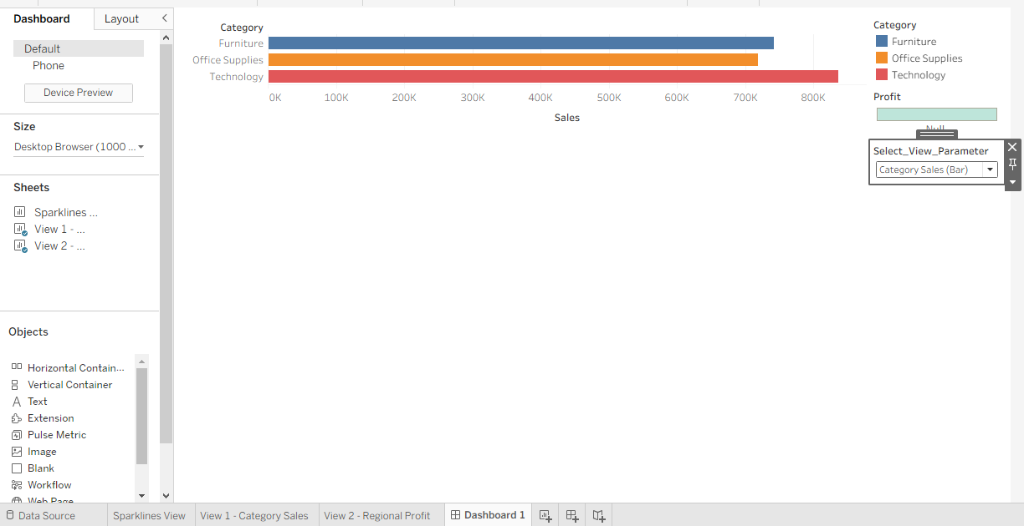
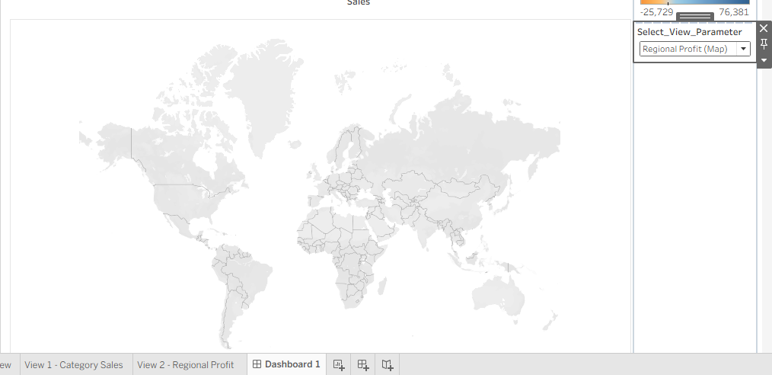

e) Create custom geographic territories
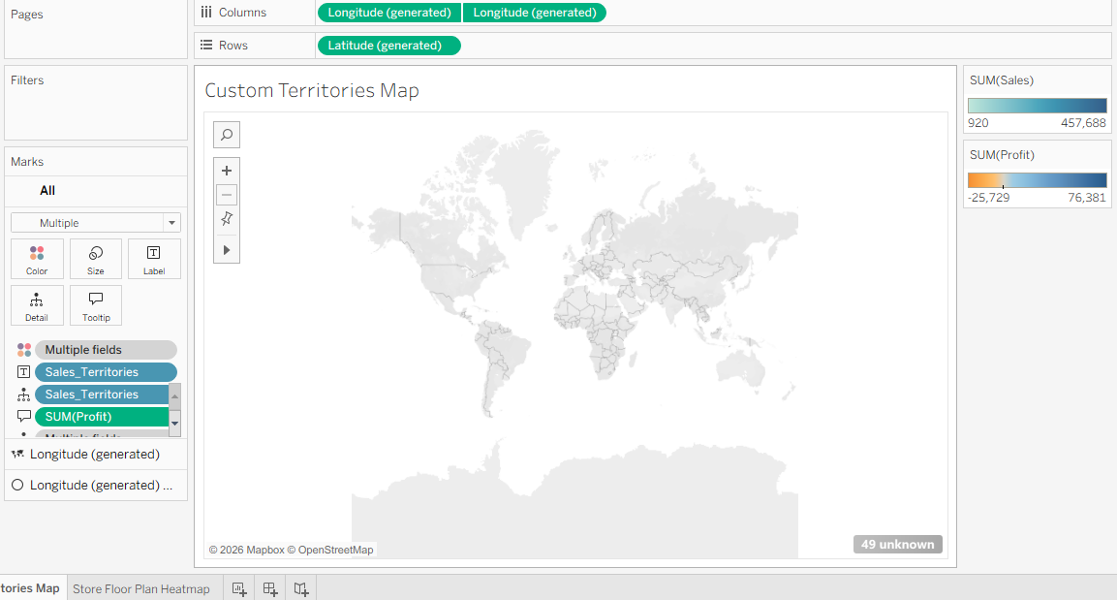
f) Use background images in dashboards
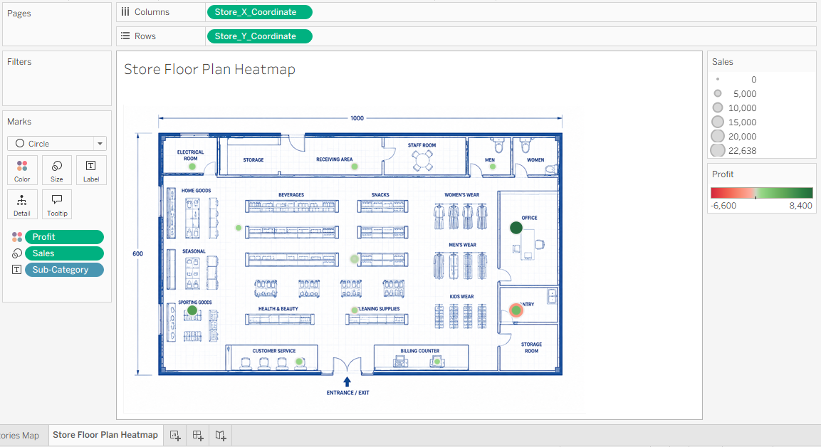

g) Apply animation and transparency techniques
